1. 
2. **Some Options**:
   1. **--nodb**: As mongo shell is javascript based. So if you want to run just js code you can do it and you don’t need to connect with db.  
      
   2. **--quite**: To see less output.  
      
   3. --port  
      --host:  
      
   4. --username:  
      --password:  
      
3. 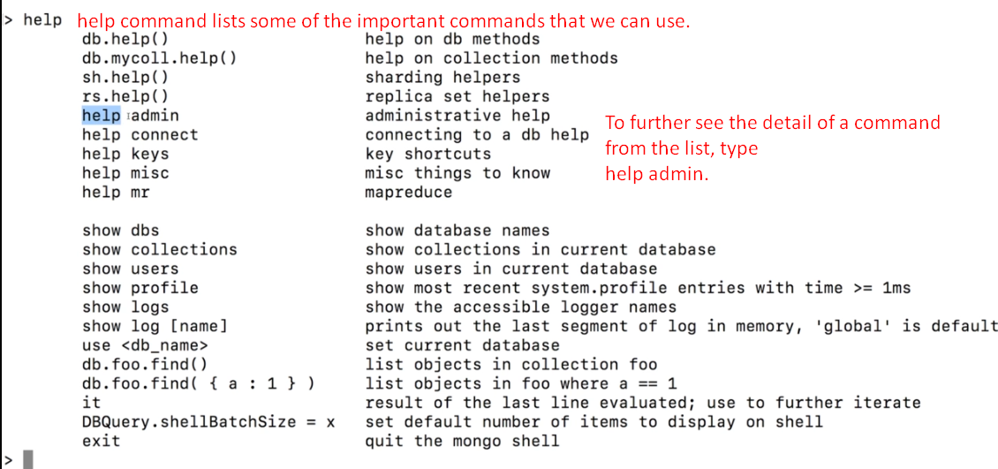
4. 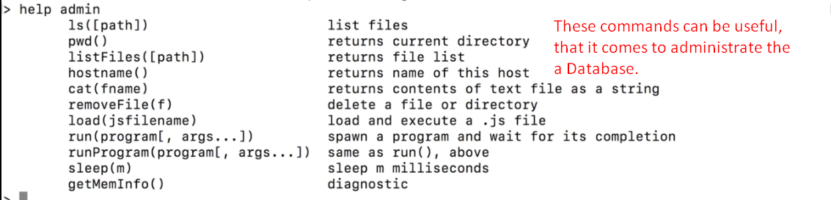
5. 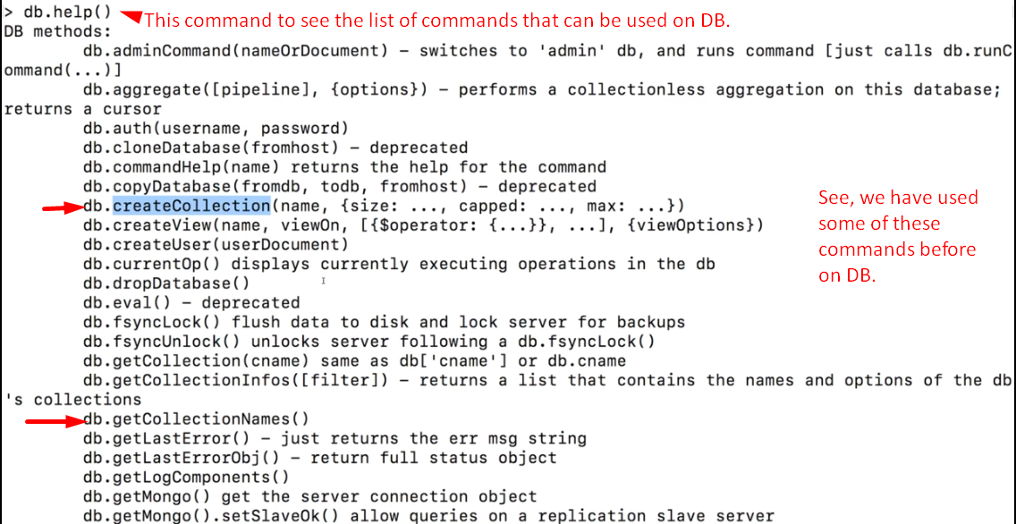
6. 